**Wealth of the Nations**

**2004-2020**

**Date of Submission – 13/04/24**

**Freddie Sherwood**

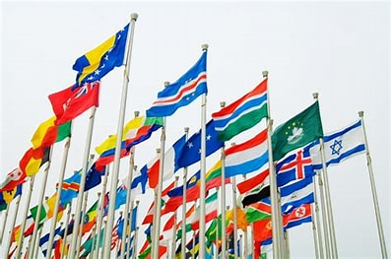

The First part of the project consisted of editing the data set into a chart containing the (top 20) Countries with their GDP, this can be seen below.

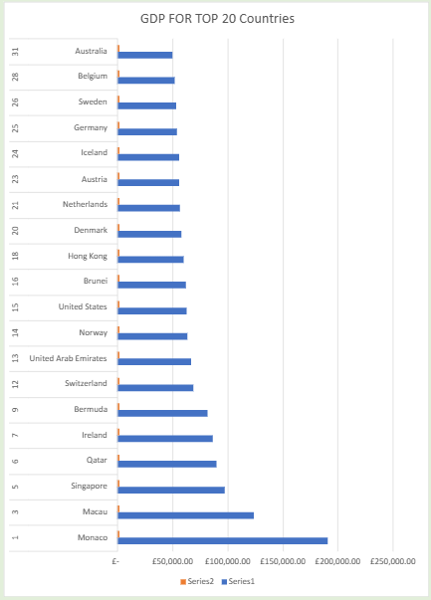

Next we moved the Data making use of macros in excel to copy and paste the chart,

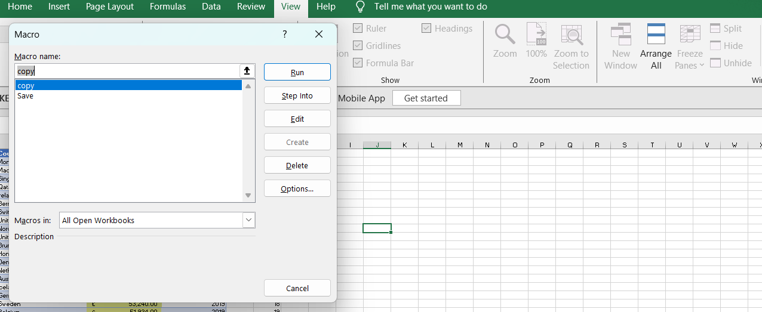

Then we used Tableau for visualization and data preview-

Here I used Tableau for formalize and visualize the data into a dashboard with different data visuals counting the top 20 of Countries,

